**AFL1C1**

**What is GSM?**

If you are in Europe or Asia and using a mobile phone, then most probably you are using GSM technology in your mobile phone.

* GSM stands for **G**lobal **S**ystem for **M**obile Communication. It is a digital cellular technology used for transmitting mobile voice and data services.
* The concept of GSM emerged from a cell-based mobile radio system at Bell Laboratories in the early 1970s.
* GSM is the name of a standardization group established in 1982 to create a common European mobile telephone standard.
* GSM is the most widely accepted standard in telecommunications and it is implemented globally.
* GSM is a circuit-switched system that divides each 200 kHz channel into eight 25 kHz time-slots. GSM operates on the mobile communication bands 900 MHz and 1800 MHz in most parts of the world. In the US, GSM operates in the bands 850 MHz and 1900 MHz.
* GSM owns a market share of more than 70 percent of the world's digital cellular subscribers.
* GSM makes use of narrowband Time Division Multiple Access (TDMA) technique for transmitting signals.
* GSM was developed using digital technology. It has an ability to carry 64 kbps to 120 Mbps of data rates.
* Presently GSM supports more than one billion mobile subscribers in more than 210 countries throughout the world.
* GSM provides basic to advanced voice and data services including roaming service. Roaming is the ability to use your GSM phone number in another GSM network.

GSM digitizes and compresses data, then sends it down through a channel with two other streams of user data, each in its own timeslot.

**Why GSM?**

Listed below are the features of GSM that account for its popularity and wide acceptance.

* Improved spectrum efficiency
* International roaming
* Low-cost mobile sets and base stations (BSs)
* High-quality speech
* Compatibility with Integrated Services Digital Network (ISDN) and other telephone company services
* Support for new services

The GSM network can be broadly divided into:

* [The Mobile Station (MS)](http://www.tutorialspoint.com/gsm/gsm_mobile_station.htm)
* [The Base Station Subsystem (BSS)](http://www.tutorialspoint.com/gsm/gsm_base_station_subsystem.htm)
* [The Network Switching Subsystem (NSS)](http://www.tutorialspoint.com/gsm/gsm_network_switching_subsystem.htm)
* [The Operation Support Subsystem (OSS)](http://www.tutorialspoint.com/gsm/gsm_operation_support_subsystem.htm)

Given below is a simple pictorial view of the GSM architecture.

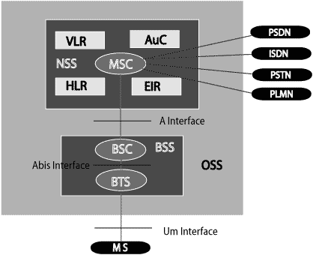

The additional components of the GSM architecture comprise of databases and messaging systems functions:

* Home Location Register (HLR)
* Visitor Location Register (VLR)
* Equipment Identity Register (EIR)
* Authentication Center (AuC)
* SMS Serving Center (SMS SC)
* Gateway MSC (GMSC)
* Chargeback Center (CBC)
* Transcoder and Adaptation Unit (TRAU)
* PSTN stands for Public Switched Telephone Network,
* PSDN stands for Public Switched Data Network and
* ISDN stands for Integrated Services Digital Network.

PSTN stands for Public Switched Telephone Network, PSDN stands for Public Switched Data Network and ISDN stands for Integrated Services Digital Network.

PSTN-Public Switched Telephone Network

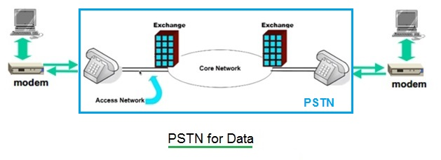

PSTN stands for Public Switched Telephone Network. It consists of access network and core network. The connection between telephone and exchange is known as access network. The connection between exchanges is known as core network.

The modem is needed to connect computer for data communication as modem converts digital data to analog form in order to transmit on analog lines. The receiver side modem converts analog data to digital data.

Following are the features of PSTN:   
• It uses circuit switching.   
• Bandwidth is reserved in advance.   
• Dedicated path is established between calling party and called party.   
• cost is based on distance and call duration or time.   
Refer [Telephone System tutorial➤](http://www.rfwireless-world.com/Tutorials/Telephone-system-tutorial.html)    [EPABX basics➤](http://www.rfwireless-world.com/Terminology/EPABX-basics.html)

PSDN-Public Switched Data Network

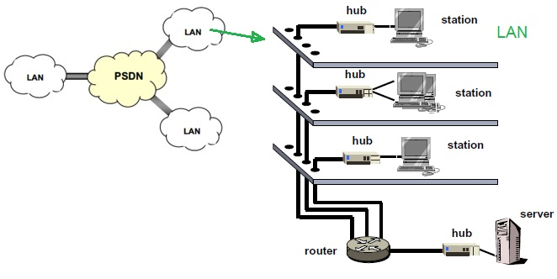

Following are the features of PSDN:   
• It is designed and developed specifically for data transmission rather than voice.   
• Communication is shared i.e. many companies share switching network.   
• It uses packet switching.   
• It acquires and releases bandwidth as needed.   
• No dedicated path exists between sender and receiver.   
• Cost is not based on distance and time. It depends on usage of the data. Cost of service is normally lower than leased line.   
Examples: [X.25](http://www.rfwireless-world.com/Tutorials/X_25_tutorial.html)   [Frame Relay](http://www.rfwireless-world.com/Tutorials/Frame-Relay-tutorial.html)   [ATM](http://www.rfwireless-world.com/Tutorials/ATM-Asynchronous-Transfer-Mode-tutorial.html)

ISDN-Integrated Services Digital Network

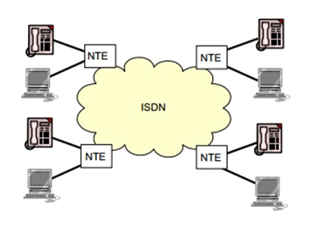

ISDN stands for Integrated Services Digital Network. It is designed for transmission of voice, data and video over digital line.

There are two forms used in ISDN viz. BRI (Basic Rate Interface) and PRI (Primary Rate Interface).   
• BRI provides two number of 64 Kbps channel and single 16 kbps control channel. Total data rate supported by BRI is 144 Kbps.   
• PRI provides 23 number of 64 kbps channel and single 64 kbps control channel. Total data rate supported by PRI is 1.544 Mbps.

The following diagram shows the GSM network along with the added elements:

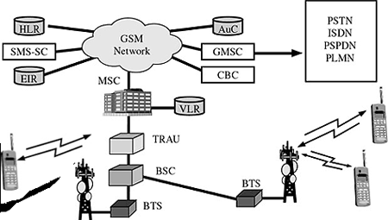

The MS and the BSS communicate across the Um interface. It is also known as the *air interface* or the *radio link*. The BSS communicates with the Network Service Switching (NSS) center across the *A* interface.

**GSM network areas**

In a GSM network, the following areas are defined:

* **Cell** : Cell is the basic service area; one BTS covers one cell. Each cell is given a Cell Global Identity (CGI), a number that uniquely identifies the cell.
* **Location Area** : A group of cells form a Location Area (LA). This is the area that is paged when a subscriber gets an incoming call. Each LA is assigned a Location Area Identity (LAI). Each LA is served by one or more BSCs.
* **MSC/VLR Service Area** : The area covered by one MSC is called the MSC/VLR service area.
* **PLMN** : The area covered by one network operator is called the Public Land Mobile Network (PLMN). A PLMN can contain one or more MSCs.

**The Mobile Station**

The MS consists of the physical equipment, such as the radio transceiver, display and digital signal processors, and the SIM card. It provides the air interface to the user in GSM networks. As such, other services are also provided, which include:

* Voice teleservices
* Data bearer services
* The features' supplementary services

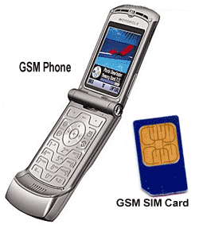

**The MS Functions**

The MS also provides the receptor for SMS messages, enabling the user to toggle between the voice and data use. Moreover, the mobile facilitates access to voice messaging systems. The MS also provides access to the various data services available in a GSM network. These data services include:

* X.25 packet switching through a synchronous or asynchronous dial-up connection to the PAD at speeds typically at 9.6 Kbps.
* General Packet Radio Services (GPRSs) using either an X.25 or IP based data transfer method at speeds up to 115 Kbps.
* High speed, circuit switched data at speeds up to 64 Kbps.

We will discuss more about GMS services in [GSM - User Services](http://www.tutorialspoint.com/gsm/gsm_user_services.htm).

**What is SIM?**

The SIM provides personal mobility so that the user can have access to all subscribed services irrespective of both the location of the terminal and the use of a specific terminal. You need to insert the SIM card into another GSM cellular phone to receive calls at that phone, make calls from that phone, or receive other subscribed services.

The BSS is composed of two parts:

* The Base Transceiver Station (BTS)
* The Base Station Controller (BSC)

**The Base Station Subsystem(BSS)**

The BTS and the BSC communicate across the specified Abis interface, enabling operations between components that are made by different suppliers. The radio components of a BSS may consist of four to seven or nine cells. A BSS may have one or more base stations. The BSS uses the Abis interface between the BTS and the BSC. A separate high-speed line (T1 or E1) is then connected from the BSS to the Mobile MSC.

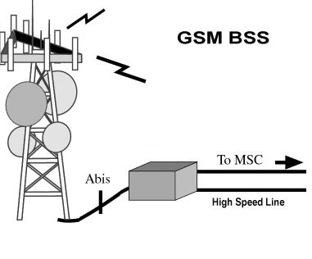

**The Base Transceiver Station (BTS)**

The BTS houses the radio transceivers that define a cell and handles the radio link protocols with the MS. In a large urban area, a large number of BTSs may be deployed.

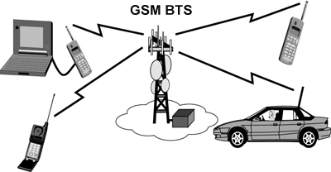

The BTS corresponds to the transceivers and antennas used in each cell of the network. A BTS is usually placed in the center of a cell. Its transmitting power defines the size of a cell. Each BTS has between 1 and 16 transceivers, depending on the density of users in the cell. Each BTS serves as a single cell. It also includes the following functions:

* Encoding, encrypting, multiplexing, modulating, and feeding the RF signals to the antenna
* Transcoding and rate adaptation
* Time and frequency synchronizing
* Voice through full- or half-rate services
* Decoding, decrypting, and equalizing received signals
* Random access detection
* Timing advances
* Uplink channel measurements

**The Base Station Controller (BSC)**

The BSC manages the radio resources for one or more BTSs. It handles radio channel setup, frequency hopping, and handovers. The BSC is the connection between the mobile and the MSC. The BSC also translates the 13 Kbps voice channel used over the radio link to the standard 64 Kbps channel used by the Public Switched Telephone Network (PSDN) or ISDN.

It assigns and releases frequencies and time slots for the MS. The BSC also handles intercell handover. It controls the power transmission of the BSS and MS in its area. The function of the BSC is to allocate the necessary time slots between the BTS and the MSC. It is a switching device that handles the radio resources. Additional functions include:

* Control of frequency hopping
* Performing traffic concentration to reduce the number of lines from the MSC
* Providing an interface to the Operations and Maintenance Center for the BSS
* Reallocation of frequencies among BTSs
* Time and frequency synchronization
* Power management
* Time-delay measurements of received signals from the MS

**The Network Switching Subsystem**

The Network switching system (NSS), the main part of which is the Mobile Switching Center (MSC), performs the switching of calls between the mobile and other fixed or mobile network users, as well as the management of mobile services such as authentication.

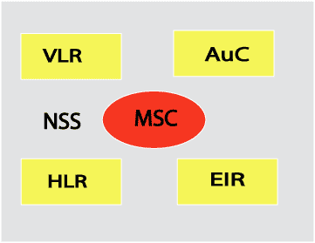

The switching system includes the following functional elements:

**Home Location Register (HLR)**

The HLR is a database used for storage and management of subscriptions. The HLR is considered the most important database, as it stores permanent data about subscribers, including a subscriber's service profile, location information, and activity status. When an individual buys a subscription in the form of SIM, then all the information about this subscription is registered in the HLR of that operator.

**Mobile Services Switching Center (MSC)**

The central component of the Network Subsystem is the MSC. The MSC performs the switching of calls between the mobile and other fixed or mobile network users, as well as the management of mobile services such as registration, authentication, location updating, handovers, and call routing to a roaming subscriber. It also performs such functions as toll ticketing, network interfacing, common channel signaling, and others. Every MSC is identified by a unique ID.

**Visitor Location Register (VLR)**

The VLR is a database that contains temporary information about subscribers that is needed by the MSC in order to service visiting subscribers. The VLR is always integrated with the MSC. When a mobile station roams into a new MSC area, the VLR connected to that MSC will request data about the mobile station from the HLR. Later, if the mobile station makes a call, the VLR will have the information needed for call setup without having to interrogate the HLR each time.

**Authentication Center (AUC)**

The Authentication Center is a protected database that stores a copy of the secret key stored in each subscriber's SIM card, which is used for authentication and ciphering of the radio channel. The AUC protects network operators from different types of fraud found in today's cellular world.

**Equipment Identity Register (EIR)**

The Equipment Identity Register (EIR) is a database that contains a list of all valid mobile equipment on the network, where its International Mobile Equipment Identity (IMEI) identifies each MS. An IMEI is marked as invalid if it has been reported stolen or is not type approved.